Strataggem Products Wiki

1. Kronos
General data about the Kronos board.

1.1 RTKronos
- Configuration of RTKronos
- Unicorecomm GPS RTK devboard
- RTKronos Communication protocol

2. Flipper

2.1 Common to Bare-Metal and Arduino
- Flashing NRF52 with slstk2010a
- Pinout of the Flipper

2.2 Use with Arduino SDK
- Setup arduino development environment for flipper
- Updating Strataggem's Arduino Board Support Package
- Description of Flipper communication buses and their use in Arduino IDE

2.3 Example of Arduino code

2.3.1 GPIO
- Use Flipper GPIO with arduino

2.3.2 SPI
- Using Flipper SD card with arduino

2.3.3 I2C
- I2C communication with an ADC : ADS1015
- I2C Communication with a particulate matter sensor : SPS30
- I2C Communication with a temperature/humidity sensor : SI7021

2.3.4 UART
- UART Communication between the flipper and a GPS Module : Ublox SAM-M8Q

2.4 CAMEL
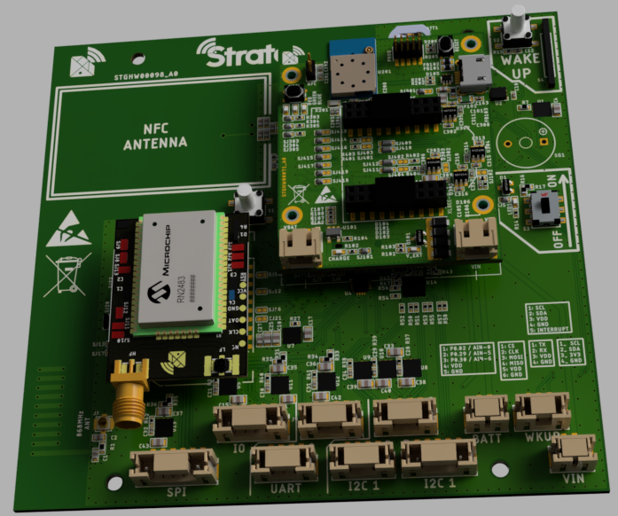

2.4.1 CAMEL V1
- Camel V1 documentation

2.4.2 CAMEL V2
- coming soon

2.5 XLBEE NRF9160
- Use the AT project: custom_serial_lte_modem
  - Compile custom_serial_lte_modem project on windows

3. Postman v1
- General documentation for the Postman v1 product

4. ecoSignal LoRaWAN gateway
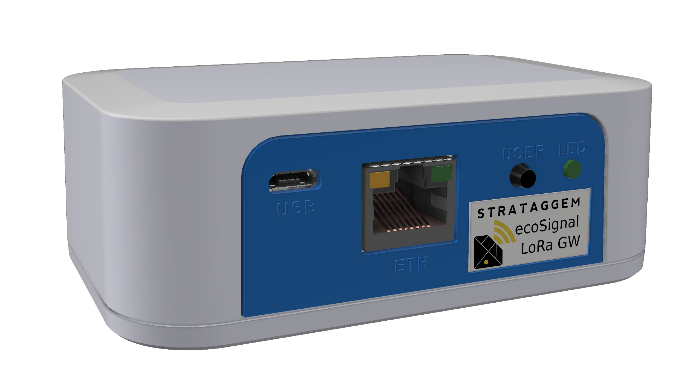
- Documentation for the ecoSignal LoRaWAN gateway

